Prime Palindrome

<HTML><HEAD >
<TITLE>Prime Palindrome</TITLE>
<SCRIPT language ="Javascript" >
function prime(n)
{
var x=0;
var c=0;
for(x=1;x<=n;x++)
{
if((n%x)==0)
{
c++;
}
}
if(c<3)
return n;
}
function palindrome(n)
{
var m = "";
var l=0;
l=l*1;
n = n.toString();
m = m.toString();
for(l=n.length;l>0;l--)
m = m + n.charAt(l-1);
n = n.toString();
m = m.toString();
if(n.match(m))
{
return n;
}
}
</SCRIPT></HEAD><BODY>
<SCRIPT language ="Javascript" >
document.fgColor="blue";
alert("This script will find all prime palindromes between two numbers.");
var a=1;
var b=1;
var c=1;
var all = new Array();
var p = new Array();
var pp = new Array();
var temp;

do
{
if((isNaN(a)+isNaN(b))>0)
alert('Please input numeric values.');
if(a<=0||b<=0)
alert('Please input positive values.');
if(a>b)
alert('The second number must be greater than the first number.');
a=prompt("Input first number:",'');
a=parseFloat(a);
c=a;
b=prompt("Input second number:",'');
b=parseFloat(b);
}
while(((isNaN(a)+isNaN(b))>0)||(a<=0||b<=0)||(a>b));
for(;a<=b;a++)
{
all.push(a);
}
while(all.length>0)
{
temp=prime(all.pop());
if (temp!=undefined)
p.push(temp);
}
while(p.length>0)
{
temp=palindrome(p.pop());
if (temp!=undefined)
pp.push(temp);
}
pp=pp.reverse();
document.write("<br>The prime palindrome(s) between " +c+ " and " +b+ " is/are:");
while(pp.length>0)
{
document.write("<br>" + pp.pop());
}
</SCRIPT></BODY></html>

Sample Run

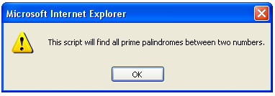

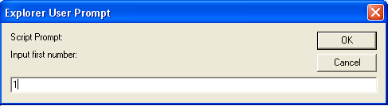

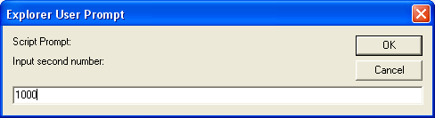

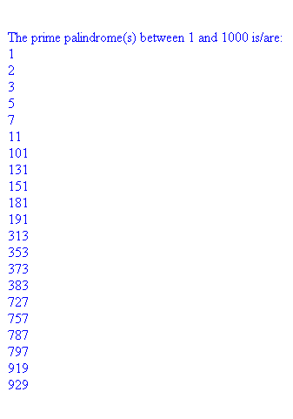

Making Change

<HTML>
<HEAD >
<TITLE>Making Change</TITLE>
</HEAD>
<BODY>
<SCRIPT language ="Javascript" >

alert("This script will compute how many ways to make change for a given amount of money.\nThe money system consists of the coins A,B,C and D where:\n5A = 1B\n2B = 1C\n2C = 1D");

var a=prompt("Enter an amount in A:","");
var b=0;
var c=0;
var d=0;
var n=1;
var s =",";

document.write("<br>#: A,B,C,D<br>");
document.write("<br>"+(n++)+": "+a+s+b+s+c+s+d);

while(a>4)
{
a=a-5;
b=b+1;
document.write("<br>"+(n++)+": "+a+s+b+s+c+s+d);
while(b>1)
{
b=b-2;
c=c+1;
document.write("<br>"+(n++)+": "+a+s+b+s+c+s+d);
while(c>1)
{
c=c-2;
d=d+1;
document.write("<br>"+(n++)+": "+a+s+b+s+c+s+d);
}
}
}

</SCRIPT>
</BODY>
</html>
Sample Run

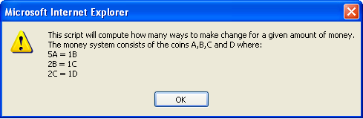

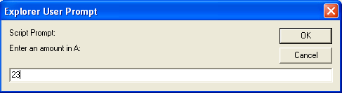

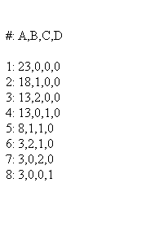

The 13th Day

<HTML>
<HEAD >
<TITLE>The 13th</TITLE>
</HEAD>
<BODY>
<SCRIPT language ="Javascript" >

alert('This script will compute the frequency that the 13th day of each month lands on Sunday, Monday, Tuesday, Wednesday, Thursday, Friday, and Saturday.');

var d=0;
var m=1;
var y=1900;
var nd=0;
var nm=0;
var ny=prompt('Input number of years:','');
ny=ny*1;

var day = new Array(0,0,0,0,0,0,0);
var dayname = new Array('Monday','Tuesday','Wednesday','Thursday','Friday','Saturday','Sunday');
var i=-1;

for(;y<(1900+ny);)
{
d++;
i++;
if(i==7)
{
i=0;
}
if(d==13)
{
day[i]++;
}
switch (m)
{
case 1 :
if(d>31)
{
d=1;
m=2;
}
break;
case 2 :
if((y%4==0)&&(d>29))
{
d=1;
m=3;
nd+=366;
}
if((y%4>0)&&(d>28))
{
d=1;
m=3;
nd+=365;
}
break;
case 3 :
if(d>31)
{
d=1;
m=4;
}
break;
case 4 :
if(d>30)
{
d=1;
m=5;
}
break;
case 5 :
if(d>31)
{
d=1;
m=6;
}
break;
break;
case 6 :
if(d>30)
{
d=1;
m=7;
}
break;
case 7 :
if(d>31)
{
d=1;
m=8;
}
break;
case 8 :
if(d>31)
{
d=1;
m=9;
}
break;
case 9 :
if(d>30)
{
d=1;
m=10;
}
break;
case 10:
if(d>31)
{
d=1;
m=11;
}
break;
case 11:
if(d>30)
{
d=1;
m=12;
}
break;
case 12:
if(d>31)
{
d=1;
m=1;
y++;
nm+=12;
}
break;
}
}

document.write('<BR>Number of years: ' + ny);
document.write('<BR>From January 1, 1900 to December 31, ' + y + '<BR>');
for(i=0;i<7;i++)
{
document.write('<BR>' + dayname[i]+': '+ day[i]);
}
</SCRIPT>
</BODY>
</html>

Sample Run

